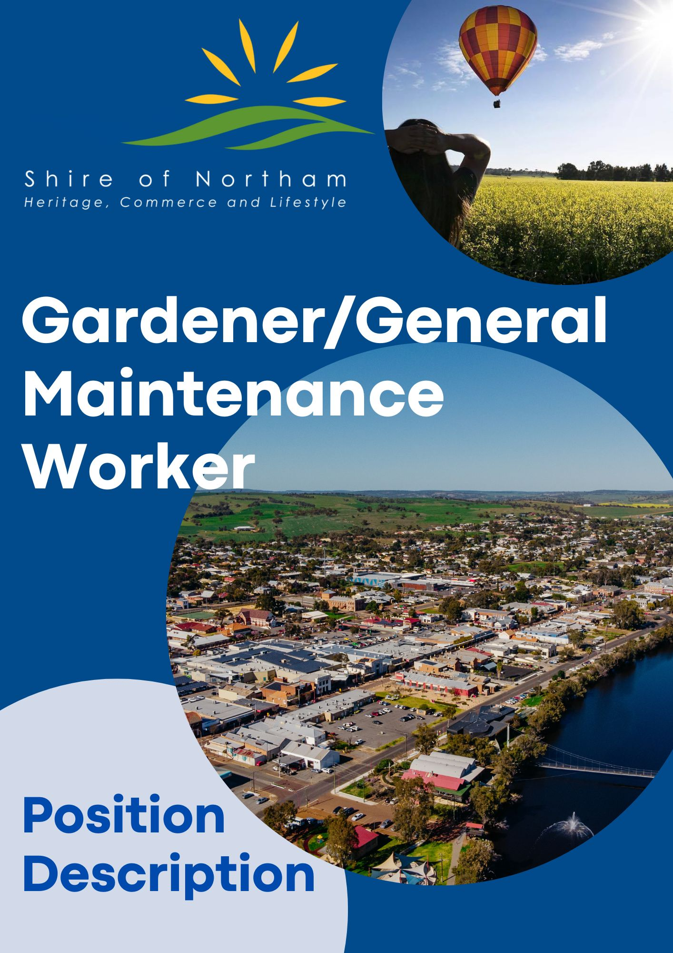

**Gardener/General**

**Maintenance Worker**

***Position Summary***

**Department:** Engineering

**Job Title:** Gardener/General Maintenance Worker

**Reports to:** Parks & Gardens Leading Hand

**Objective:** This position maintains Parks and Gardens within the Shire of Northam under the direction of the Parks and Gardens Leading Hand. This includes grounds maintenance, maintaining plants and planted areas, landscape construction and applying treatments to improve plant growth and control pests.

**Work Location:** Administration

**Award/Level:** Local Government Industry Award 2020, Level 6/1

**Date Revised:** August 2021

**Responsibilities and Duties**

* Maintain lawn and grass areas using machinery, fertilisers and chemicals.
* Basic servicing of equipment such as tools, lawn mowers and heavy machinery as per the schedule required.
* Operate and install irrigation and drainage systems as directed.
* Prepare garden beds or lawn areas by cultivating soil and adding fertilisers and compost, using growth regulators and other chemicals.
* Identify and correct soil deficiencies and treat pests and diseases affecting plants.
* Read landscape plans and construct rockeries, paths or ponds.
* Plant and transplant flowers, shrubs, trees and lawns.
* Maintain gardens by fertilising, trimming and making sure that plants are receiving adequate water.
* Any other duties consistent with the level of the position as directed

**Organisational**

* Embrace, support and participate in change to assist in achieving the Shire’s goals and objectives.
* The ability to maintain strict confidentiality is an essential requirement of all employees of the Shire.
* Actively participate in the ongoing development, compliance and promotion of professional customer service standards.
* Recommend changes or strategies which promote a ‘Continual Improvement’ and ‘Best Practice’ approach to service delivery.
* Promote, maintain, and improve the working environment and practices to ensure compliance with Industrial Awards, Work Health and Safety, Diversity Equal Employment Opportunities (EEO) legislation and Council’s Policies and Procedures.

**Work Health and Safety, Employee Requirements**

Employees are responsible and accountable for:

* Complying with workplace procedures for risk identification, risk assessment & risk control
* Participation in activities associated with the management of workplace health & safety.
* Identification and reporting of health and safety risks, accidents, incidents, injuries, property damage and mishaps at the workplace
* Correct utilization of appropriate personal protective equipment
* Promote, maintain, and improve the working environment and practices to ensure compliance with Industrial Awards, Workplace Health & Safety, EEO legislation and Council’s Policies and Procedures
* Ensure that safety inspections are carried out at all events, and that events are conducted in line with relevant risk management plans and guidelines.

**Authority and Accountability**

Problems at this level require employees to use some originality in approach with solutions usually attributable to application of previously encountered solutions or experience. More complex problems or issues can be referred to the Parks and Gardens Leading Hand.

|  |  |  |
| --- | --- | --- |
| **POSITION REQUIREMENTS** |  |  |
| **Documents** | **Essential** | **Desirable** |
| * Hold a current unrestricted C Class national drivers licence |  |  |
| * Provision of a current National Police Clearance |  |  |
| * Hold a WA Construction White Card |  |  |
| **Skills and Abilities** |  |  |
| * Willingness to operate plant and equipment as required within the scope of the incumbent’s drivers licence. |  |  |
| * Willingness to undertake training in the operation of plant and equipment as required. |  |  |
| * Developed oral and written literacy and numeracy skills. |  |  |
| * The ability to work within a team environment & to liaise effectively and professionally with customers if required. |  |  |
| * Experienced in the safe operation and maintenance of medium to high complexity mechanical plant, including a sound working knowledge of WorkSAFE WA requirements. |  |  |
| * Ability to read and understand labels in relation to chemical use. |  |  |
| * Demonstrated experience in landscape construction, grounds maintenance, turf management and nursery practice and plant cultivation. |  |  |
| * Demonstrated experience in nursery practice and plant cultivation. |  |  |
| * Demonstrated experience in chemical handling and application practice |  |  |
| * Demonstrated experience in irrigation maintenance, in the operation of machinery associated with horticulture practice. |  |  |
| * Hold a current unrestricted HR class national drivers licence |  |  |

**GENERAL PHYSICAL REQUIREMENTS**

|  |  |  |  |  |
| --- | --- | --- | --- | --- |
|  |  |  |  |  |
| **Task** | **Mainly** | **Frequently** | **Occasionally** | **N/A** |
| Stand |  |  |  |  |
| Walk |  |  |  |  |
| Sit |  |  |  |  |
| Handle |  |  |  |  |
| Reach |  |  |  |  |
| Climb/Balance |  |  |  |  |
| Crouch/Kneel |  |  |  |  |
| Talk/Hear |  |  |  |  |
| Taste/Smell |  |  |  |  |
|  |  |  |  |  |

**Authorisation and Acknowledgement**

|  |
| --- |
| I acknowledge that I have read and understood the key objectives, duties, responsibilities and other requirements as outlined in this position description.  I understand that this position description provides general guidance regarding the purpose of the position and my responsibilities.  Furthermore, I acknowledge that this position description may be amended from time to time to reflect changes to the position or Shire requirements. |
| Employee Signature: Date: |

