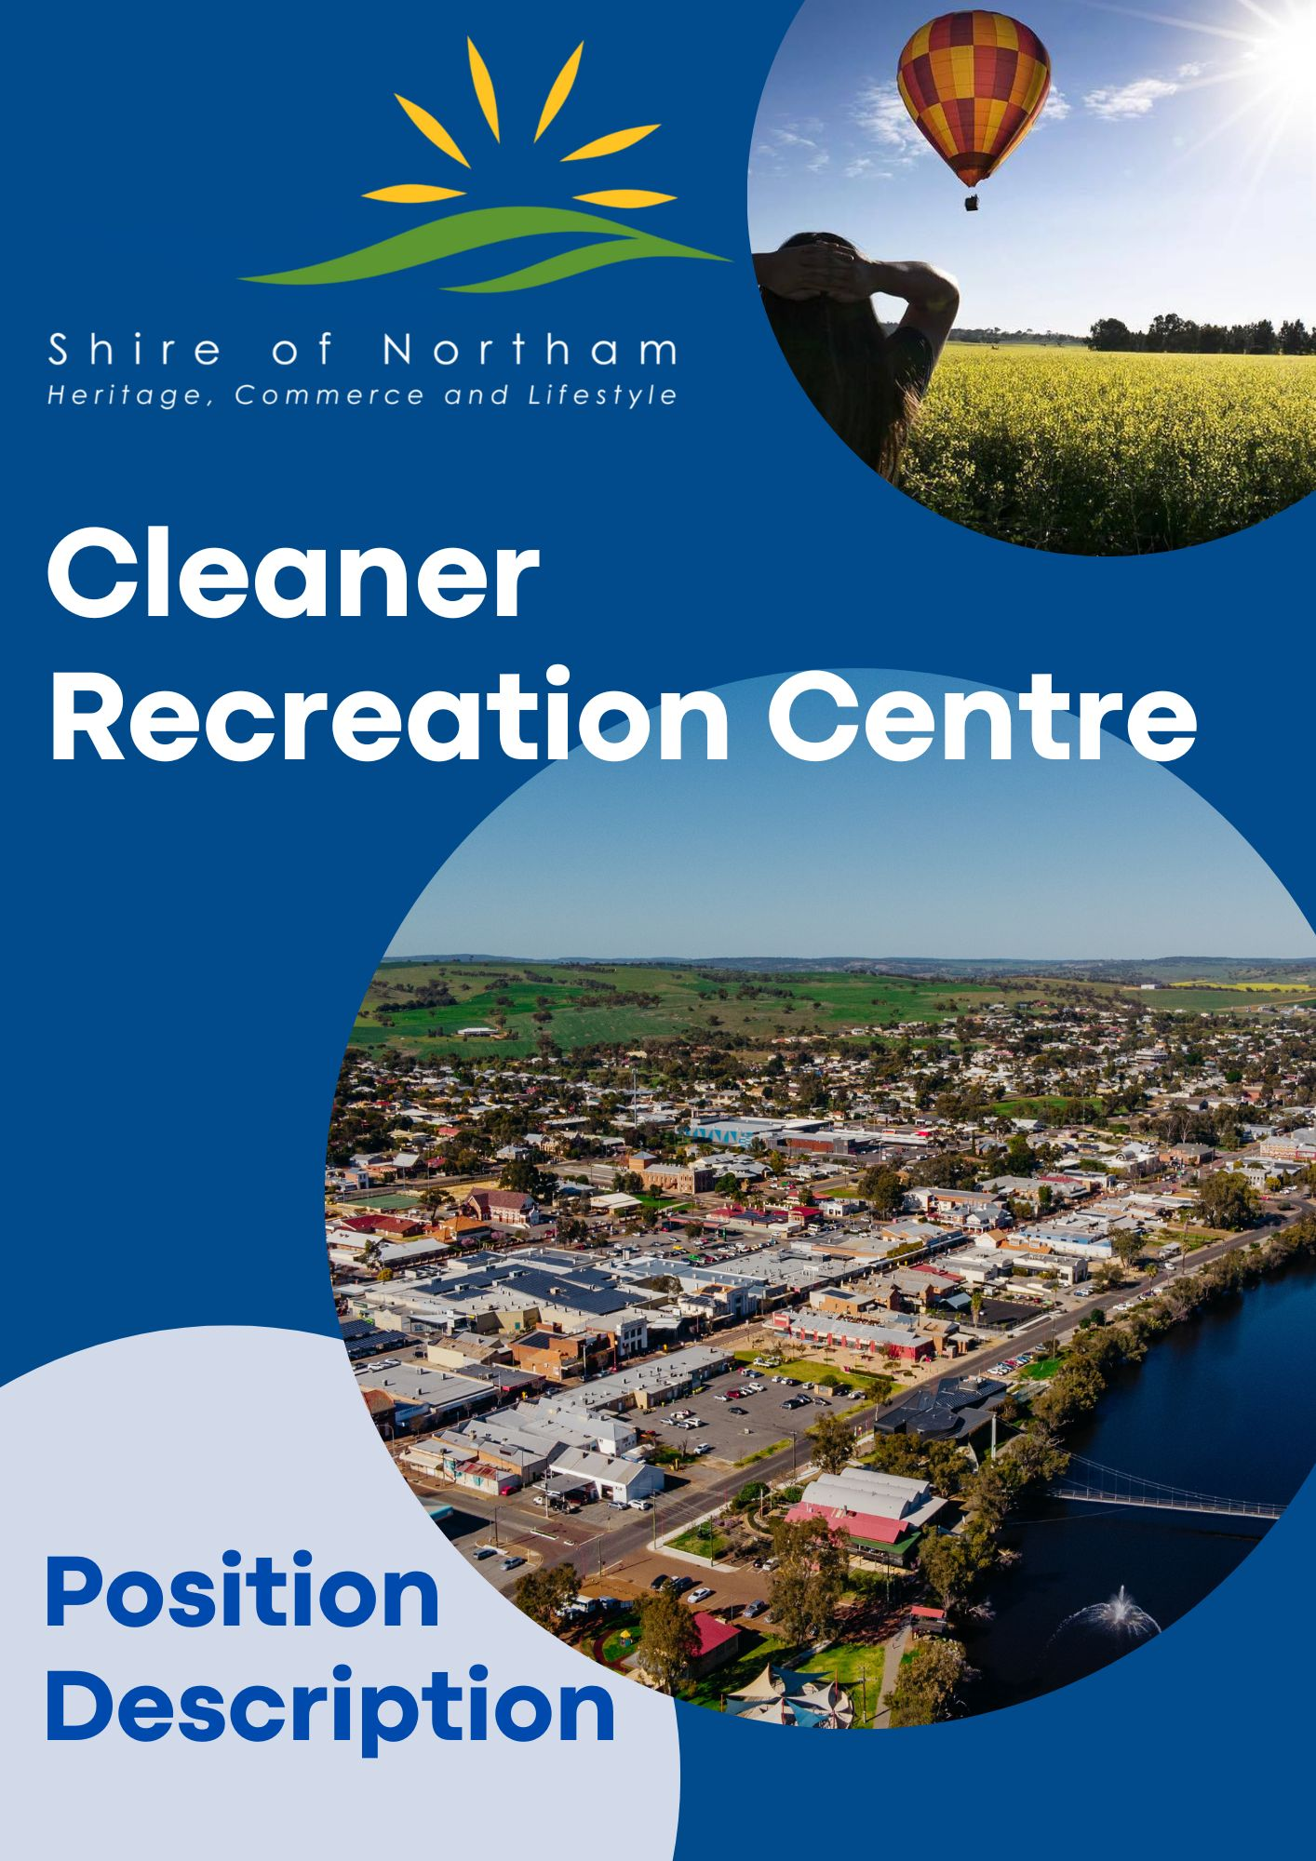

**Cleaner**

**Recreation Centre**

***Position Summary***

**Department:** Community Services

**Job Title:** Cleaner Recreation Centre

**Reports to:** Manager Recreation and Youth Services

**Objective:** Clean and maintain amenities and facilities within the Shire of Northam recreational areas in accordance with occupational, health and safety, risk management and quality hygiene service standard requirements. Promote a positive image for the Shire through the professional delivery of service.

**Work Location:** Recreation Centre

**Award/Level:** Local Government Industry Award 2020, Level 3/1

**Date Revised:** March 2022

**Responsibilities and Duties**

* Carry out general cleaning duties within specified areas nominated by the Supervisor i.e., aquatics, admin, court sports, hospitality, halls
* Clean allocated areas to an extremely high standard with consideration to hygiene, safety whilst maintaining a high level of customer awareness.
* Immediately respond to any cleaning requirement that poses any danger or risk to the health and safety of customers and / or employees.
* Exercise duty of care and work in a safe and efficient manner, having regard for your own safety and that of other workers and customers of the Shire of Northam.
* Maintain all cleaning equipment in good working order, reporting any damage to equipment or hazards in the work area to the supervisor as soon as possible.
* Ensure workplace procedures and instructions for controlling risks are followed accurately and ensure that all cleaning equipment and chemicals are stored securely after use.
* Ensure that reports on accidents and incidents are provided to the immediate supervisor.
* Assist others in the work team with implementing risk management policies and procedures.
* Maintain security awareness when undertaking tasks remotely or independently, including locking doors, setting alarms and reporting all suspicious activities to the supervisor.
* Provide support to, and relief of, other cleaning positions in other areas and locations, as required.
* Any other duties consistent with the level of the position as directed.

**Organisational**

* Embrace, support and participate in change to assist in achieving the Shire’s goals and objectives.
* The ability to maintain strict confidentiality is an essential requirement of all employees of the Shire.
* Actively participate in the ongoing development, compliance and promotion of professional customer service standards.
* Recommend changes or strategies which promote a ‘Continual Improvement’ and ‘Best Practice’ approach to service delivery.
* Promote, maintain, and improve the working environment and practices to ensure compliance with Industrial Awards, Work Health and Safety, Diversity Equal Employment Opportunities (EEO) legislation and Council’s Policies and Procedures.

**Work Health and Safety, Employee Requirements**

Employees are responsible and accountable for:

* Complying with workplace procedures for risk identification, risk assessment and risk control
* Participation in activities associated with the management of workplace health & safety.
* Identification and reporting of health and safety risks, accidents, incidents, injuries, property damage and mishaps at the workplace
* Correct utilization of appropriate personal protective equipment
* Promote, maintain, and improve the working environment and practices to ensure compliance with Industrial Awards, Workplace Health & Safety, EEO legislation and Council’s Policies and Procedures
* Ensure that safety inspections are carried out at all events, and that events are conducted in line with relevant risk management plans and guidelines.

**Authority and Accountability**

Excellent work ethics (i.e. pride in work, reliable, well presented, punctual).

|  |  |  |
| --- | --- | --- |
| **POSITION REQUIREMENTS** |  |  |
| **Documents** | **Essential** | **Desirable** |
| * Hold a current unrestricted C Class national drivers licence |  |  |
| * Provision of a current National Police Clearance |  |  |
| **Skills and Abilities** |  |  |
| * Flexible approach to working locations and work hours. |  |  |
| * Effective interpersonal and customer relation skills. |  |  |
| * Ability to work effectively both independently and in a team environment. |  |  |
| * Ability to prioritise work and attend to urgent clearning requirements immediately. |  |  |
| * Demonstrated experience in commercial cleaning and/or cleaning of public amenities. |  |  |
| * Proven understanding of occupational safety and health requirements relevant to the position, including the safe handling procedures for sharps and cleaning products. |  |  |
| * Experience and skills in basic maintenance skills, such as basic carpentry, painting and repairing. |  |  |
| * Experience in the operation of small plant and equipment, such as high pressure cleaners, basic power tools, etc. |  |  |
| * Current immunisation for Hepatitis A and Hepatitis B |  |  |
| * Training in handling chemicals |  |  |

**GENERAL PHYSICAL REQUIREMENTS**

|  |  |  |  |  |
| --- | --- | --- | --- | --- |
|  |  |  |  |  |
| **Task** | **Mainly** | **Frequently** | **Occasionally** | **N/A** |
| Stand |  |  |  |  |
| Walk |  |  |  |  |
| Sit |  |  |  |  |
| Handle |  |  |  |  |
| Reach |  |  |  |  |
| Climb/Balance |  |  |  |  |
| Crouch/Kneel |  |  |  |  |
| Talk/Hear |  |  |  |  |
| Taste/Smell |  |  |  |  |
|  |  |  |  |  |

**Authorisation and Acknowledgement**

|  |
| --- |
| I acknowledge that I have read and understood the key objectives, duties, responsibilities and other requirements as outlined in this position description.  I understand that this position description provides general guidance regarding the purpose of the position and my responsibilities.  Furthermore, I acknowledge that this position description may be amended from time to time to reflect changes to the position or Shire requirements. |
| Employee Signature: Date: |

